Sponsorships and Donations

Sponsor a hole or donate golfing awards or raffle prizes.

_____ Sponsor a hole which will include your business name on signage at the hole. Donation of $100 for each hole sponsored.

_____ Donation of prizes or money to be used for golfing awards and raffle prizes.

Description of donation:

Company Name:

Contact Name:

Phone Number:

Checks should be made payable to

Charleston Metal Products

Please contact Joel Conrad at Charleston Metal Products at 260-837-8211 for any sponsorship questions.

A Note to Our

Sponsors and Participants

Charleston Metal Products thanks each of you for helping to make this fund raiser a success. All proceeds raised from this golf outing will be provided to the United Way of DeKalb County in support of their partner agencies who help make a difference within our community.

This event is open to all of our employees, their families and friends, as well as our customers, suppliers, and business partners who help make Charleston Metal Products a successful part of our community. We hope you are able to join us on Saturday August 10th to enjoy some fellowship and fun while giving back to our community. Living United!!



**Charleston**

**Metal Products, Inc.**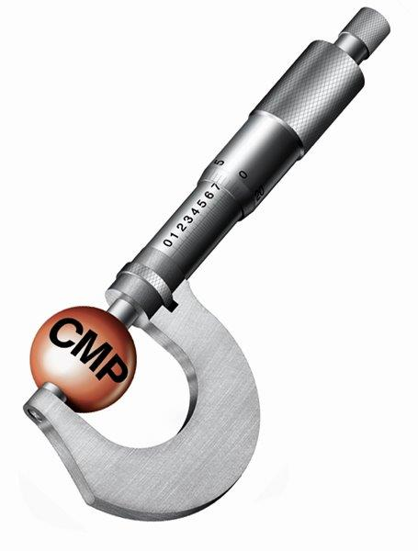

**Golf Outing in support of the United Way of**

**DeKalb County**

**August 10, 2024**

**Garrett Country Club**

401 N. Walsh Street, Garrett, IN 46738

Prizes

1st Place Low Score, 2nd Place Low Score, Last Place Highest Score, Longest Drive, Closest to the Pin, and Longest Putt. Hole-In-One contest with a $7,500 grand prize!!

Optional Events

Hole # 6 will be our casino hole where you can bet $5, $10 or $20 on getting your golf ball on the green from the Tee Box. Chance to double your money if you are successful.

Mulligan Eagle Bags for $10 each. Includes 1 White Tee that can be used once for a mulligan from the Tee Box, 1 Red Tee that can be used once to place your ball on and strike from the fairway or rough, and a 3 foot string that can be used once to pick up a ball that is within 3 feet of the hole without using a stroke. One bag per player limit.

Raffle Tickets will be sold for door prizes. $2 each, 3 for $5, 8 for $10 or 20 for $20.

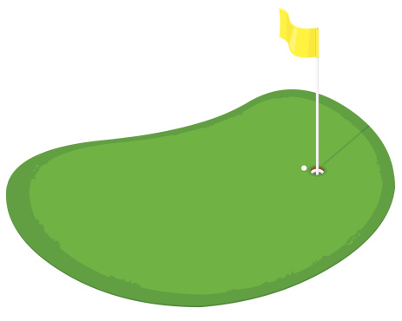

Saturday, August 10, 2024

7:00 AM – Registration with coffee and donuts provided

7:50 AM – Meeting and announcements at the club house prior to traveling to starting hole

8:00 AM - Four Person Scramble

with Shotgun Start (men using blue tees, seniors (65+) using white tees, women using red tees)

Lunch includes Hamburger, Brat,

Chips, and Desert

Contests and Prizes

Longest Drive

Closest to the Pin

Longest Putt

Last Place Team

2nd Place Team

1st Place Team

Hole – In – One

Team Registration

$360 per team or $90 per player

Team Captain: _________________

Cell Phone: ___________________

Player #2: ___________________

Player #3: ___________________

Player #4: ___________________

# of Mulligan Eagle

Bags @ $10 each: __________

Total Amount Enclosed: _________

Please return registration form

and payment no later than

Friday, July 26th to:

**Charleston Metal Products, 350 Grant Street, Waterloo, Indiana 46793, Attention: H R Department**

Checks should be made payable to

Charleston Metal Products

Please contact Joel Conrad at 260-837-8211 if you have any questions.